

**Information Systems Projects Management**

**Student Name: Alaa Zohdy Badwan**

**Student ID: 0189409**

**Section: 2 (8:30-10.00)**

**Gamification Approaches for Education and**

**Engagement on Pro-Environmental Behaviors:**

**Searching for Best Practices**

**Tania Ouariachi *, Chih-Yen Li and Wim J. L. Elving**

Professorship Communication, Behaviour & the Sustainable Society, EnTranCe, Center of Expertise Energy,

Hanze University of Applied Sciences, Zernikeplein 7, 9747 AS Groningen, The Netherlands;

yen32754@gmail.com (C.-Y.L.); w.j.l.elving@pl.hanze.nl (W.J.L.E.)

**\*** Correspondence: t.ouariachi.peralta@pl.hanze.nl

Received: 22 March 2020; Accepted: 1 June 2020; Published: 3 June 2020

Table of Content

Abstract……………………………………………………………….4

Introduction…………………………………………………………4

A New Education Paradigm: From Information Exposure to Action4..............................................

Gamification Behavioral Change…………………………..5

Theoretical Framework…………………………………………5

Material and Methods…………………………………………. 5

Results…………………………………………………………………..6

Discussion and Conclusion…………………………………….8

**Abstract:**

Education is a key factor to respond to the threat of climate change, increasing not only knowledge but also encouraging changes in attitudes and behaviors to adopt sustainable lifestyles. Scholars and practitioners in the field of education call for innovative ways of engaging youth—a reason why gamification has gained more attention in recent years. This paper aims at exploring the role of gamification in affecting pro-environmental behavioral change and searching for best practices for educational purposes. For that aim, pro-environmental gamification platforms are identified and analyzed by applying two different frameworks: the Octalysis Framework and the Climate Change Engagement through Games Framework. After scanning 181 cases, a final sample of six is analyzed and two of them are selected as best practices with higher potential to engage users in pro-environmental behavioral change: SaveOhno and JouleBug. Meaning, ownership, and social influence, as well as achievability, challenge, and credibility, are seen as core elements that can increase the success of gamification platforms. In conclusion, the more attributes are enclosed in the gamification design, the stronger physical and mental connections it builds up with participants. Insights from this study can help educators to select best practices and gamification designers to better influence behavioral change through game mechanics.

**Introduction:**

Early in the late 19th century, scientists already gave a warning about the emission of carbon dioxide, saying it might lead to global warming.

Since climate change is a global issue and cannot be solved by a single person, it is necessary to expand awareness and empower people to deal with this topic.

However, raising awareness of environmental issues is just the beginning Governments, communication and education specialists, and environmental activists are suggesting taking a further step, beyond raising awareness and knowledge, to encouraging people to change behaviors to mitigate the stress of the earth. The use of gamification in education has been applied to formal and non-formal education settings.

**A New Education Paradigm: From Information Exposure to Action**

Learning to build a better planet than today requires a holistic approach.

Promoting equitable, inclusive, and fair societies requires creating processes for citizen participation that imply “shared decision-making” and an assumption of responsibilities in favor of global sustainability.

Different models have been developed by scholars trying to explain this new paradigm. Visual images play an important role in this type of strategy. Manzo emphasizes the power of the influences that images have, and how images are a double-edged sword in changing people’s attitudes.

# Gamification and Behavioral Change

Define gamification as “the use of game design elements in non-game contexts”. Definition of gamification, other authors like Werbach redefine the concept into “the process of making activities more game-like”, proclaiming that not every non-game context includes game design elements is considered to be gamified.

In 2016, Mazur-Stommen and Farley included behavior change in the definition of gamification.

Extrinsic motivation relies on external stimulation to change the behavior, while intrinsic motivation is driven by oneself, suggest not only visible game elements such as points, badges, leaderboards, performance graphs, meaningful stories, avatars, and teammates should be considered, but also players’ need for psychological satisfaction, including the need for competence, autonomy, and social relatedness should be included during the design of gamification tools.

# Theoretical Frameworks

Gamification theories at the early stage focus on giving definitions and examining when this core driver is used correctly, it promotes strong and long-lasting motivations to become engaged. The framework consists of 15 key game attributes classified in three dimensions: 1. Emotional involvement: what and how strongly people feel about climate change. These are social, efficacy-enhancing, reward-driven, leveling up, fun, achievable, feedback-oriented, meaningful, narrative-driven, simulating. Ideally, to create inspiring tools, there is a need to appeal, not only to the analytical processing system, but to the overall experiential system, playing with reality, highlighting powerful narratives that connect with people’s values and experiences, and paying careful attention to both verbal, written and audio-visual communication.

# Materials and Methods

Since the role of gamification in affecting pro-environmental behavioral change is a relatively new topic, this exploratory study makes use of qualitative research methods.

Two different stages can be distinguished in the study: The first stage: is identification and selection. To identify pro-environmental gamification platforms, a literature review was carried out in Scopus and Google Scholar, as well as a web search in the main search engines using the following keywords: (climate change/ global warming/ environment/ sustainability) and (communication/ education/ behavior) and (gamification/ gamified system/ gratifying/ game elements) in both English and Mandarin, the working languages of the researchers. To analyze the selected cases, first of all, the Octalysis framework was applied via an online tool where two researchers can provide scores to the eight different drivers and fill each empty section every core drive was evaluated from 0–to 10. The qualitative content analysis focuses on manifest and latent features, entailing quantification by coding frequencies to detect patterns in the data.

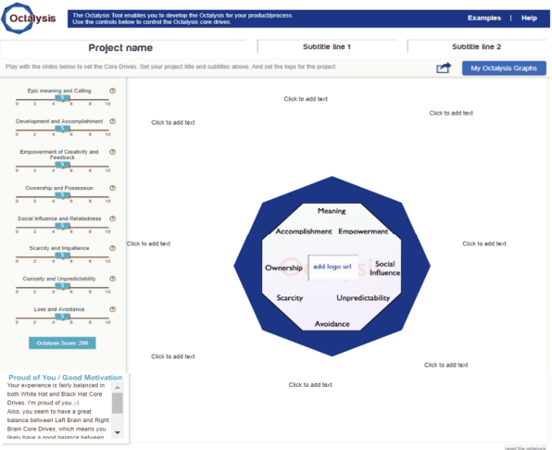

The integration of two different models in this second stage of qualitative content analysis relies on the need for:

1) adding theoretical triangulation in exploratory studies.

2) integrating the strengths of each model. Both models follow the same goal; however, while the first focuses mostly on gamification as the tool, the second one focuses on climate-change-related issues as the main topic.

# Results

One of the first observations was that gamification platforms with an educational purpose are quite popular, especially digital ones and on mobile devices, they are usually used for promoting behavioral change but also to raise awareness of certain topics, including formats such as simulations, strategic games, and news games.

Developers include commercial, charitable, educational, and governmental organizations, yet, only the well-known dominant gamified designs can receive up to 8 or 9 points on the specific core drive(s), as stated by Chou, the following analysis also checked the referring tips on the website in case of interpretation errors.

Below is the analysis of the final six selected cases:

1. Recyclebank (score: <50): an online gamified platform allowing visitors to earn points from reading articles, doing small tests, recycling, and playing small games to enhance climate change-related knowledge. However, the commercial-oriented rewarding system, as well as scarce exclusive discounts, could decrease the users’ feeling of doing meaningful work and intentions of modifying behavior. In this case, white hat gamification receives greater attention, while black hat motivations such as Scarcity and Impatience, Unpredictability and Curiosity, and Loss and Avoidance, which can stimulate an instant response, are avoided. By deciding whether other users’ eco-friendly actions are meaningful, receiving followers, or participating in group campaigns, players are empowered as social influencers to affect the others on the platform. Core drivers: Social Influence and Relatedness, Epic Meaning and Calling, and Development and Accomplishment are the three strongest core drives offering extra points to beginners that can ensure players stay longer in the application. The application provides multiple options for users to choose their desired behavior modifications. This specific case seems to also find a balance between white and black hat motivations. As observed in the cases above, the six selected gamification platforms apply different motivation elements based on the design purpose and its target audience. Left-brain and black hat core drives provide hooks to attract participants to exploring the gamification platforms within a short time and urgently encourage them to perform certain actions, while right-brain and white hat drives keep users staying longer and remaining positive in the platforms.

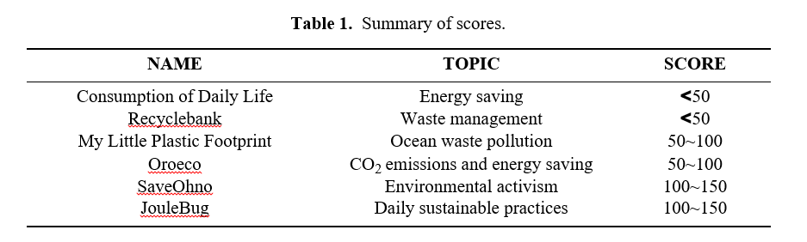

Application of Climate Change Engagement through Games Framework After exploring how motivation core drives work in the six selected cases and examining how those motivators shape participant pro-environmental behavior, now we explore the capacity of these gamification platforms to engage participants at the cognitive, emotional, and behavioral levels. A checklist based on the Climate Change Engagement through Games Framework is applied to the six cases.

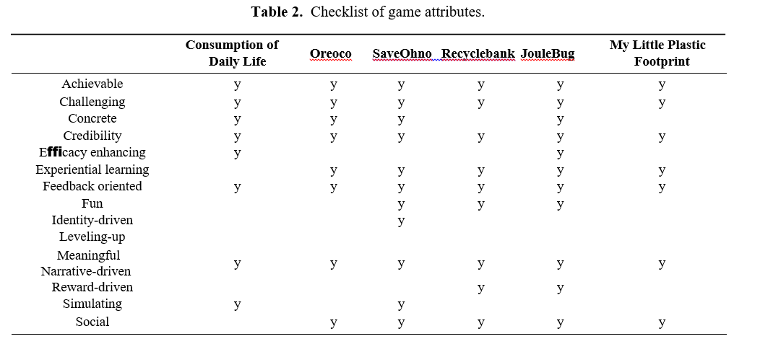

The two gamification cases that scored higher through the Octalysis Framework , SaveOhno and JouleBug also enclose more game attributes from the Climate Change Engagement through Games Framework, which means that their potential is higher to engage players not only at the cognitive and emotional levels but also behavioral level.SaveOhno does not score in efficacy-enhancing, leveling-up, or reward-driven characteristics, yet all cognitive, emotional, and behavioral dimensions contain at least one attribute (Figure2a).Figure3shows that there are five attributes applied in all six cases:

* Achievable: promoting possible actions within the reach of the individual.
* Challenging: a task that requires a certain degree of effort to perform.
* Credibility: trustworthy information and inspiration.
* Feedback-oriented: evaluation of current performance relative to goal.
* Meaningful: evoking intense feelings.

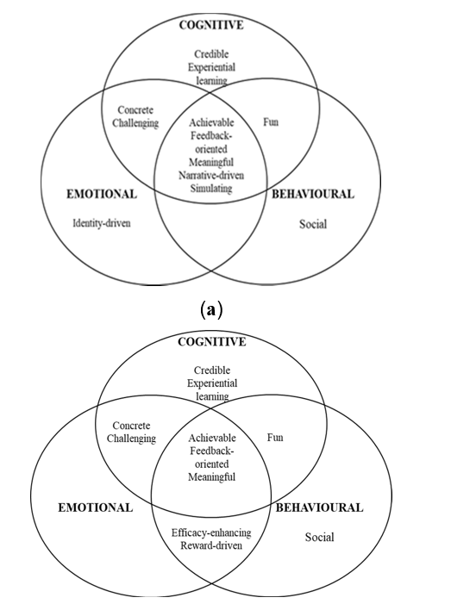

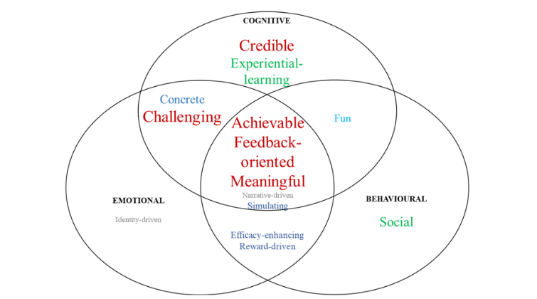

# Discussion and Conclusions

# For a long time, scholars, practitioners, and activists have mainly put the focus on delivering pro-environmental messages to the public.

# Recently, the field of climate and environmental education has gone beyond transferring knowledge and values to also create a fluid process that encourages concrete actions by stimulating interest and nurturing participation.

# This study concludes that gamification approaches have the potential to educate and encourage pro-environmental behavioral change, as long as they combine in their design extrinsic and intrinsic motivational elements, short-term and long-term drivers, and game attributes that encourage taking action in real life.

# We recognize issues with sample and selection. In addition, there is a lack of previous studies on this very specific field. Future academic studies are recommended to test the applicability of the Octalysis Framework and the Climate Change Engagement through Game Framework in predicting pro-environmental engagement.